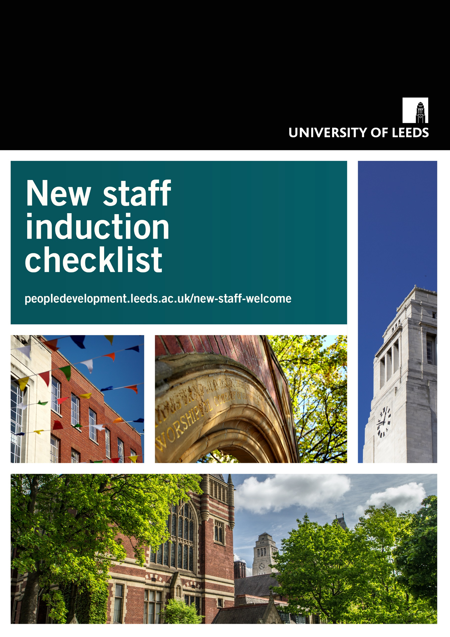

University of Leeds Induction Checklist

How to use this document
The following guidance is intended to help the person responsible for inducting the new member of staff. It's not an exhaustive list and can be modified to incorporate local induction practices. This is an editable version of the checklist – this information is also available on induction webpages on the OD&PL website. The induction checklist should be jointly completed with the new member of staff and the person responsible for inducting them. Preparation before the new person arrives is to be done by the person responsible for inducting.

Prepare for arrival

The following are things you'll need to do before the new appointee's first day. This is the responsibility of the person inducting the new appointee.

Prepare induction
HR will send the new appointee their contract and payroll form. In addition, you will need to prepare an induction for the new staff member which will consist of:
- Information provided in this checklist along with local induction information from your department
- Information from the IT induction checklist e.g. ordering a laptop
- Departmental structure chart
- Arrange introductory meetings and schedule the new starter's first weeks at the University
- Share the HR webpage - Joining the University: things you need to know with the new staff member
- University staff no longer need to apply for a username as this will be created automatically once an active SAP record has been created

Confirm first day arrangements with new staff member
- Advise where, when and who to report to on their first day and advise of working time and break arrangements
- Offer the opportunity to discuss any reasonable adjustments that need to be made both now and in the future
- Provide details of their induction programme
- Provide contact details in case of questions or the need to report absence etc

Prepare for first week
Get relevant documentation together e.g., departmental contacts, University strategy and values, school/service plan, relevant policies, and procedures.
Start to introduce the new colleague to the department - this can be done by email and on Teams to introduce the new colleague and assign a mentor/‘buddy’/probationary adviser.
You will also need to:
- Add their name to relevant staff lists
- Arrange any passwords needed for SAP, KRISTAL etc
- A new Teams Voice number can be requested via IT by the new appointee once they have an IT log in - this is solely for anyone who also needs to 'receive' external calls, all permanent staff members are able to make external calls by default
On Campus:
- Organise and arrange workspace
- Make sure any personal and desk stationery is ordered
- Get keys cut and fobs created and arrange any access needed to restricted areas

First day at the University

The following are the things we'd recommend introducing on the first day.

An introduction to the University
- Introduction to the University of Leeds Strategy 2020-2030 and the Enabling Strategy which supports it
- Introduction to the values and responsibilities at the University
- Introduction to how our University operates
- Introduction to the HE sector
- To view a map of campus

An introduction to the department
- Brief description of the department and how it fits within the University
- Introduce the department, service or school strategic plan and objectives, showing where it aligns to the wider University Strategic Plan
- Explain the management structure of your department and who the post-holder reports to on a day-to-day basis
- Invite new staff member to relevant team meetings

Roles and responsibilities
- Explain their individual duties and go through their job description and discuss role objectives
- Introduction to other staff, explain their roles and encourage them to make introduction meetings
- Ensure the new starter is aware of the University welcome event for new staff and book on to the next event
- Arrange for inclusion on departmental web site (where relevant)
- Discuss working times e.g., start and finish times, lunch breaks and overtime where appropriate
- Offer the opportunity to discuss any reasonable adjustments which need to be made with either their manager or HR

Health and safety
- Fire evacuation procedures – cover the fire alarm and evacuation procedure in the area
- Local first aid and calling an ambulance – show where to find first aid supplies, introduce the first aider and cover how to summon an ambulance (call 999 + security)
- Local Health & Safety information – introduce the safety information within the school or service relevant to the role
To view more information, you can visit the staff induction page on the Wellbeing, Safety and Health site on the Staff Intranet.

Working on campus
- Arrange an appointment with PCB for staff ID
- Security office - telephone number for emergencies (32222)
- Reporting suspect packages/people
- Ensure cars and offices are locked when left
- Non-liability of University in insurance claims for loss of property
- Departmental alarms, videos, secure areas
- Departmental Critical Incident Management Plan and new appointee's emergency contact number and next of kin contact details
- Location of toilets, coffee room/kitchen, drinking water, first aid (or rest) rooms, photocopier, mail delivery location etc.
- Issue keys and pin-numbers if appropriate

First week and onwards at the University

The following are things we'd recommend discussing in the first week and onwards. This will change depending on the needs of the role.

Campus Facilities
- Explore campus: Visit the around campus webpage to explore our academic facilities, social space and campus landmarks
- Eating on campus: Explore our range of Great Food at Leeds coffee shops and the Refectory
- Staff Centre: Connect, rebalance and learn at the Wellbeing Hub (formerly the LOGIK Centre)
- Car Parking. Find out more about car parking on campus, including registration of vehicle / parking discs / parking regulations
- Sport & Physical Activity: Find out more about our campus sport and fitness facilities
- The Student Union – LUU bars, shops and food stands
- Libraries: Explore the vast range of resources for staff from the Library
- Information for disabled visitors: Here you can find useful information for visiting campus
- Prayer Facilities: Find out more about our prayer and contemplation spaces on campus
- Green spaces on campus: Explore green spaces on campus to relax and visit on campus

Computing and Library
- Online IT induction
- Using the Library
- Notify staff of relevant systems e.g., Publications Database for Academic staff, SAP and arrange training if necessary

Enhance your digital capabilities:
  - This Jisc Discovery Tool is available to all colleagues, they can use it to assess and enhance their digital capabilities. They will be recommended areas for development, along with a series of resources.
  - LinkedIn Learning has a number of courses available to support colleagues to enhance their digital capabilities, and it is available to all staff for free. Colleagues can also access the digital essentials training collection, created by OD&PL, via LinkedIn Learning.

Communications
Make staff aware of the best practice guidance provided by the communications team:
- Commissioning communications and marketing materials such as video, graphic design, web design and build and stills photography, all of which are subject to EU procurement guidelines
- Advice on a range of topics such as commissioning outside agencies, writing for the web, media training, public engagement, use of brand guidelines and social media best practice
Internal Communications channels at the University of Leeds:
- Staff Intranet - The Staff Intranet provides a single source of trusted information about the University to help employees perform at their best. Explore the latest University news, as well as straightforward access to the tools, resources, policies and information you need in your work at Leeds.
- All Staff enews - eNews is our weekly newsletter sharing major University announcements, policies, developments, dates, deadlines, success stories and ‘calls to action’ that are relevant to colleagues. It is emailed to you directly every Wednesday- previous staff email communications can be found on the Staff Intranet.
- Staff X (Formerly Twitter) account @UniLeedsStaff

Equality & Inclusion Unit
The University of Leeds believes that every student, staff and other member of our community should be treated with dignity and mutual respect, creating a learning and working environment which is free from barriers. To look at more information about Equality & Inclusion you can look at the Equality & Inclusion Unit SharePoint site.
- The University has multiple Staff Equity Networks which are organised by staff for staff, providing a space for staff to reach out to colleagues outside of the University’s support services.
- The policy on Dignity and Mutual Respect
- It is important that we capture and keep Equality Data on the Manager/Employee Self Service Information site up to date. You can do this by logging onto HR Self-Service, clicking Personal Information and then the Personal Profile link. Select the Equality Data tab, click the Edit (pencil) icon on the right-hand side of the screen, amend the fields as required using the drop-down menus and click save

Mandatory Information and Training

Mandatory HR information:
- Introduce to the HR website and the HR SharePoint site, which is part of the Staff Intranet
- Explain the local process for sickness and absence (see policy section)
- Outline their annual leave entitlement and the procedure for booking.
- Go through the probationary process and procedure
- Give information and contact details of appropriate staff outside department e.g. RIS, IT, HR, OD&PL etc.

University mandatory training:
- All staff must annually complete the Information Governance training programme, hosted in Learning Pool (requires login). You will receive an email from the Learning Pool system once you have been enrolled, with guidance on how to access the training.
- All staff must be aware of the Code of Conduct and complete the online Professional Behaviours and Relationships training on Minerva.
- The Introduction to Equality and Inclusion module on Minerva (requires login) provides all staff with a baseline perspective on Equality and Inclusion at Leeds.
- The Sustainability in Practice module on Minerva (requires login) is appropriate for all staff and is designed to explore the fundamentals of sustainability. You will explore what sustainability is, why it is important and what part you can play.
- Mandatory Health and Safety e-learning - Staff need to complete the three short online modules on Fire Safety, Manual Handling and Display Screen Equipment (DSE).
To access e-learning modules on Minerva, log in using your University IT details and click on the Organisations tab on the left of the screen.

People Development
The University offers an extensive range of development opportunities for all staff. It is the responsibility of both individuals and their managers to define their development needs as part of setting their individual targets and objectives.
- Introduce them to the OD&PL website which covers support in the following areas: Leadership and Professional Practice, Student Education Development, Researcher Development and Culture and Digital Practice. Colleagues can also find development opportunities via the OD&PL SharePoint site which is part of the Staff Intranet.
- Introduction to probation and the Staff Review & Development Scheme (SRDS)
- Explain that as a member of staff they will have free access to LinkedIn Learning which has over 21,000 courses
The following OD&PL provision is relevant if the staff member is responsible for leading and managing people:
- Review Management Essentials suite of courses and the wider Management Development Programmes
- The Leadership Development Programmes

Policies
There are a variety of different policies and procedures which new staff will find useful. HR policies, such as Annual Leave, Conduct and Sickness & Absence can be found on the Policy Hub on the Staff Intranet. The Policy Hub also includes policies relating to students, research, finance, IT, sustainability, and other University-wide policies.
Other policies which will be of interest are also listed here:
- Copyright information on the Library website
- Data Protection Code of Practice
- Equality and Inclusion Policies and Guidance
- Finance policies on the Finance SharePoint site
- Freedom of Information requests at Leeds
- Health & Safety policy
- Information Protection Policy
- Intellectual Property Policy (PDF)
- Learning and teaching policies and procedures
- Purchasing SharePoint site
- Smoking regulations and policy
- The Leeds Partnership
- University Publications Policy

Staff Benefits
All staff have access to a wide range of staff benefits, from support and advice at work to discounts on shopping and leisure.

Sustainability at the University
Sustainability sits at the heart of The University of Leeds. We take our responsibility to have a positive impact on society and the environment very seriously and believe that we all have a part to play in this. The Sustainability Service oversee the University’s Sustainability Strategy and support the University to deliver it. All staff should be aware of the strategy and how they can contribute to sustainability at the University.
Sustainability Training - All staff are required to complete two training modules available on Minerva, the Sustainability in Practice training module and the University Environmental Management System (EMS) module.
For staff groups who do not have computer access, for further information and access to the training and resources, please contact sustainability@leeds.ac.uk who can organise face-to-face/paper-based inductions.
Key Sustainability commitments - Staff should be aware of specific University commitments in relation to sustainability:
- Our 7 Principles for Climate Action
- Single-use Plastic Free Pledge
- The UN Sustainable Development Goals
Sustainability opportunities at the University - Staff should be aware of the opportunities to get involved with sustainability. Please review the dedicated induction page within the Sustainability Staff Knowledge Hub.

Trade Unions

UCU
Why join the University and College Union? UCU is the trade union that is officially recognised by Leeds University to negotiate on behalf of academic and academic-related (professional and managerial) staff. By joining UCU you will be able to:
- Benefit from advice and support (including, if necessary, legal advice) on difficulties that arise in the workplace after you have joined the Union
- Have your say in shaping UCU's position in negotiations with Leeds University about our terms and conditions
- Be part of the organisation that negotiates at national level on the pay, pensions, and working conditions of academic and academic-related staff
The Leeds UCU branch is one of the largest in the country and we have taken a lead role both locally and in terms of national policy in combating casualisation and improving migrant workers' rights.
Our size puts us in a strong position when negotiating when negotiating to improve the working conditions of our members at Leeds, but this will only remain the case if new staff join!
On our website you can Join UCU and find out more about the UCU Leeds Branch.

Unison
Unison is the trade union that is officially recognised by Leeds University to negotiate on behalf of support staff and support-related (professional and managerial) staff.
What is the role of a union? Unions negotiate on behalf of their members for better pay and conditions, help individuals in trouble, and campaign for a safer, fairer University and society. As a member of a union you are also entitled to an array of discounts and benefits.
Why join UNISON? By joining the University of Leeds Unison Branch, you will be joining over 1200 colleagues who are members of Unison. Each of these members have their own reasons for joining UNISON and you can see just a few of them on our website.
As a member you will be able to access the following benefits:
- Unrivalled protection and representation at work
- Help with your pay and conditions of service
- Health and safety guidance and support
- Confidential welfare services for you and your dependents in difficult times
- Education and training advice and courses
- special deals on a range of things from computers, holidays, mortgages, insurance, and car breakdown services to tax returns and credit cards.
As a Branch, we also run regular socials for our members; prize draws; free days out to the seaside and the Durham Miners’ Gala in summer and a free trip to a Christmas market in December.
Our Education Fund offers members one part-time, non-work-related course per academic year, part or fully-funded by the Branch, we send out emails on how to participate throughout the year but we regularly share news updates and information on what is happening around campus on our social media.
Our website provides more information about joining Unison and the costs associated and if you do decide to join, you can join Unison via our website.
If you have any questions about joining, you can contact our membership officer at l.j.bowler@leeds.ac.uk or contact our branch office directly at unison@leeds.ac.uk.

Unite
The University of Leeds Unite Branch is very active both locally and nationally supporting individual members and national initiatives allowing for a greater understanding of technicians’ issues. Nationally, Unite the Union has 1.42 million members making it the largest union in the UK and Ireland. The role of Unite, with the other two recognised unions at the university (Unison and UCU), is to negotiate, and consult with management on behalf of all staff but individually it represents its members.
The University of Leeds branch of Unite holds meetings on a monthly basis to allow members to find out and discuss general university issues with officers and representatives. Anyone with a personal issue can contact a rep separately, who’ll involve one of the officers, if necessary. These monthly meetings allow the Union’s branch officers to communicate issues affecting its members during regular meetings with management. At the heart of the Unite the Union’s branch at the University is a need to ensure that its members’ voices, most of whom are technicians, are heard within the university.
For further details contact:
- Unite - Central Contact E: Unite@leeds.ac.uk
- Jo Westerman – Branch Chair E: Westerman@leeds.ac.uk
- Neil Lowley – Branch Secretary E: A.Lowley@leeds.ac.uk
- Clare Freer – Branch Equalities E: McCartney@leeds.ac.uk
- Romain Cames – Branch Health and safety E: Cames@leeds.ac.uk

Wellbeing, Safety and Health

Health and Safety:
- Overall safety points for becoming accustomed to working in a new area - cover important safety requirements for the role, the training required and where to ask questions or report problems
- Personal Health and Safety responsibilities - ensure new starter is clear that they have important safety responsibilities to themselves and others. Also see the University Health and Safety Policy (see policies section)
- Local safety information and risk assessments - show relevant safety documents/information needed to understand safety implications
- Reporting hazards and concerns - ensure new starter knows who to speak to about safety matters
- Key safety contacts - identify and (if possible) meet those in safety-related roles such as first aider, fire warden, H&S Coordinator etc
- Accident reporting - identify where to report accidents or incidents
- Occupational Health Service (OHS) - introduce OHS and review surveillance requirements associated with the role
- Additional induction and safety training - point new starter to any additional inductions or training needed within the school/service
- More information on all these points can be found on the Health & Safety staff induction page.

Wellbeing:
- Occupational Health
- Staff Counselling & Psychological Support Service
- Sport and Physical Activity
- Wellbeing Safety and Health
- The University’s commitment to supporting the mental health of staff

